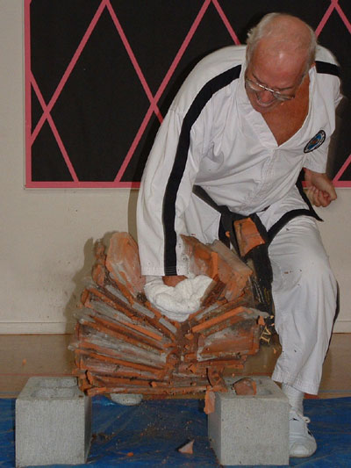
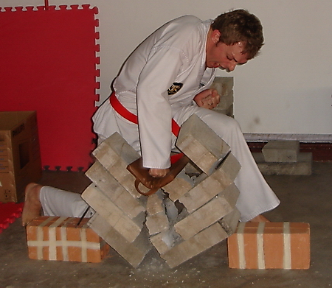
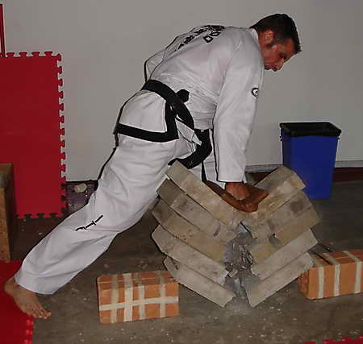
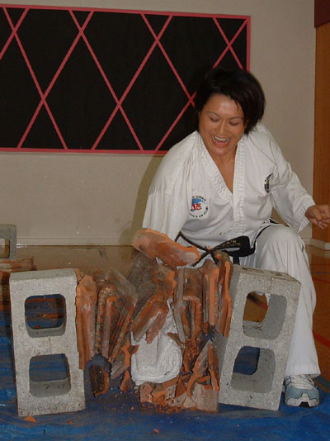
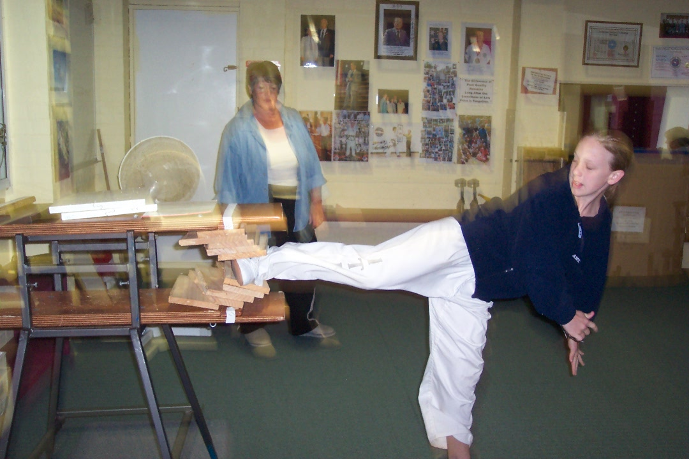
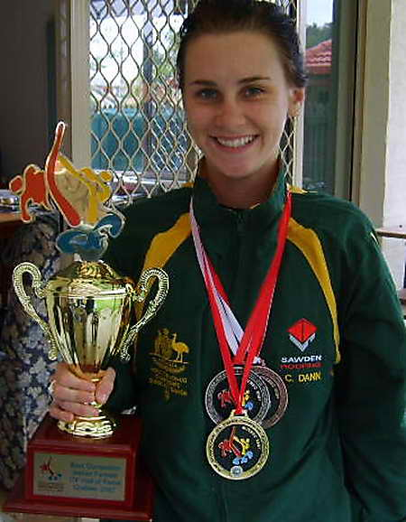
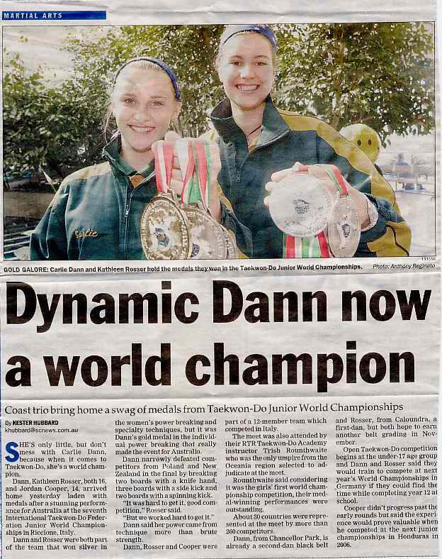

Power Breaking Seminar
Auckland
Sunday 31st July 8.30am – 3.30pm
Learn from World Champion Power Breaking Coaches
Master Rocky and Mrs Trish Rounthwaite, Mr Jon Sawden
Man Cave 198 Marua Rd, Ellerslie
Green belt and above – 14 yrs and above
Includes coloured belt breaking requirements
$45 individual, $85 family of two, $90 family of three or more.
Multiple breaking stations – limited to 30 students
Pre seminar registration required http://itkd.co.nz/events/register/event.php
Coordinator – Hannah Honey 021576210
(Pay on the day)

